Mongodb week 12 Task

1. **Create Operation:**

Q. Create a new database named "library" and switch to it.

Ans:- use library

-Q. Create a collection named "books" with fields: title, author, and published_year.

Ans:- db.createCollection("books")

-Q. Insert a document into the "books" collection with the details of your favorite book.

Ans:- db.books.insert({

title: "The Great Gatsby",

author: "F. Scott Fitzgerald",

published_year: 1925

})

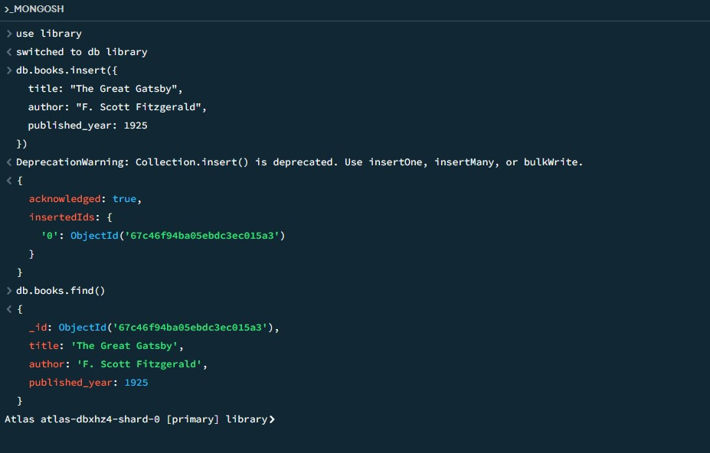

2. **Read Operation:**

Q. Retrieve all documents from the "books" collection.

Ans:- db.books.find()

Q. Find and display only the documents where the author is "J.K. Rowling".

Ans:- db.books.find({ author: "J.K. Rowling" })

Q. Fetch and display the document with the earliest published year.

Ans:- db.books.find().sort({ published_year: 1 }).limit(1)

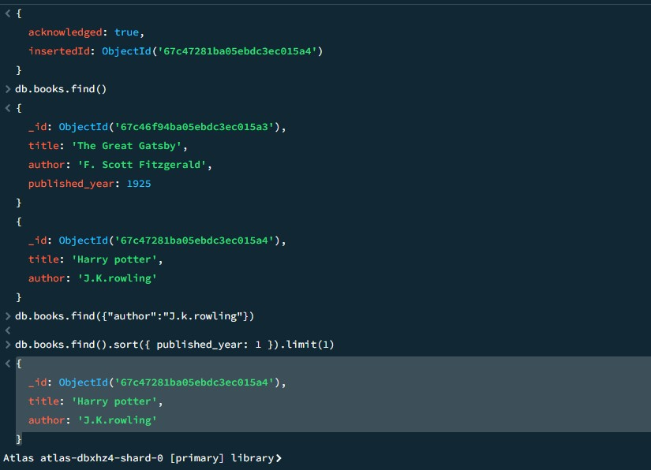

3. **Update Operation:**

-Q. Update the published year of the book with the title "The Catcher in the Rye" to the current year.

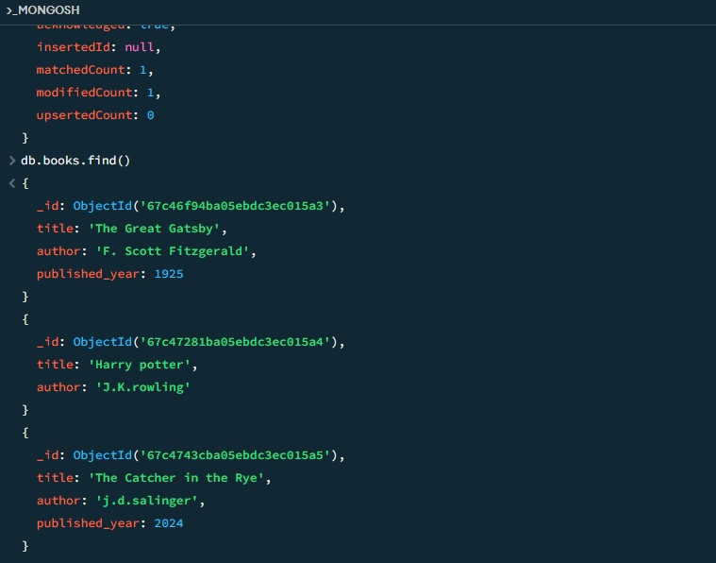

Q.Add a new field "genre" with the value "Mystery" to all documents in the "books" collection.



4. **Delete Operation:**

-Q. Remove the document with the title "1984" from the "books" collection.

Ans:-

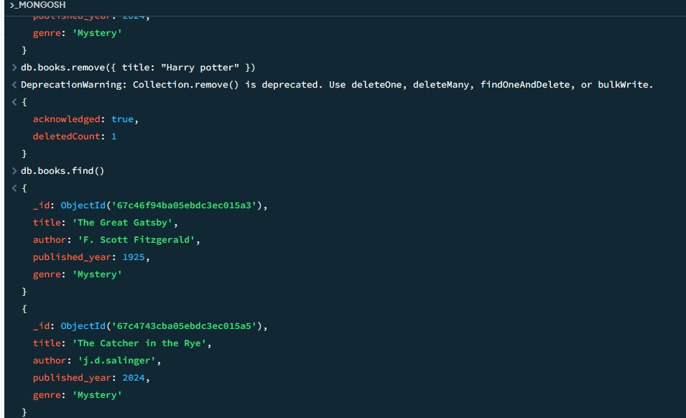

Q. Delete all documents from the "books" collection where the published year is before 2000.

Ans:-

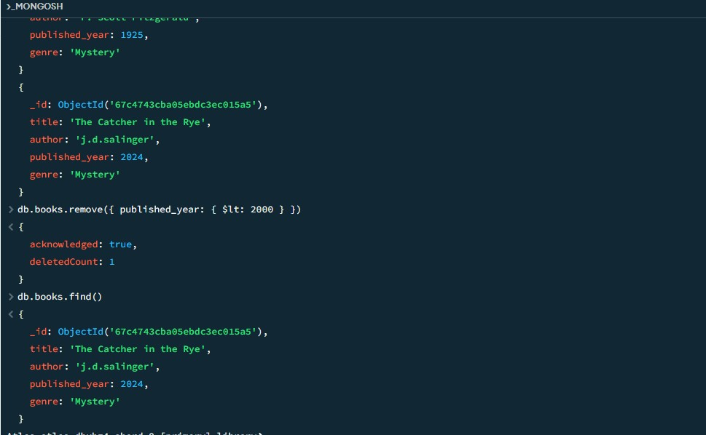

5. **Advanced Query:**

Q. Find and display the top 3 recently published books from the "books" collection.

Ans:- db.books.find().sort({ published_date: -1 }).limit(3);

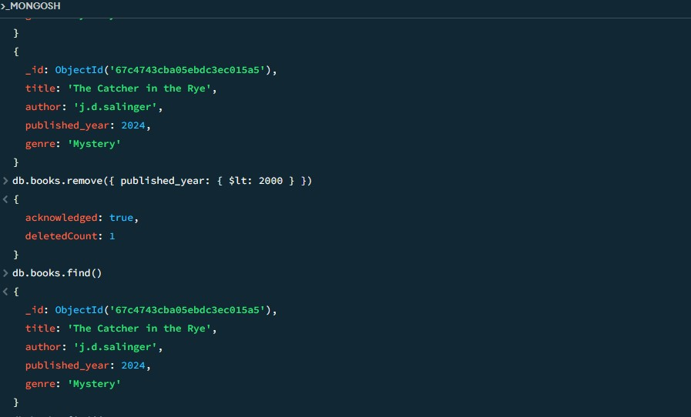

-Q. Retrieve documents from the "books" collection where the title contains the word "MongoDB" or "NoSQL".

Ans:- db.books.find({

title: { $regex: "MongoDB|NoSQL”}

});